Computing Exp 5

Task: Create a server client connection that works for 10+ clients which is like a broadcast group, any user can send message which then will be broadcasted and the server sends message to all users if a new user joins or an old user leaves.

Server side:
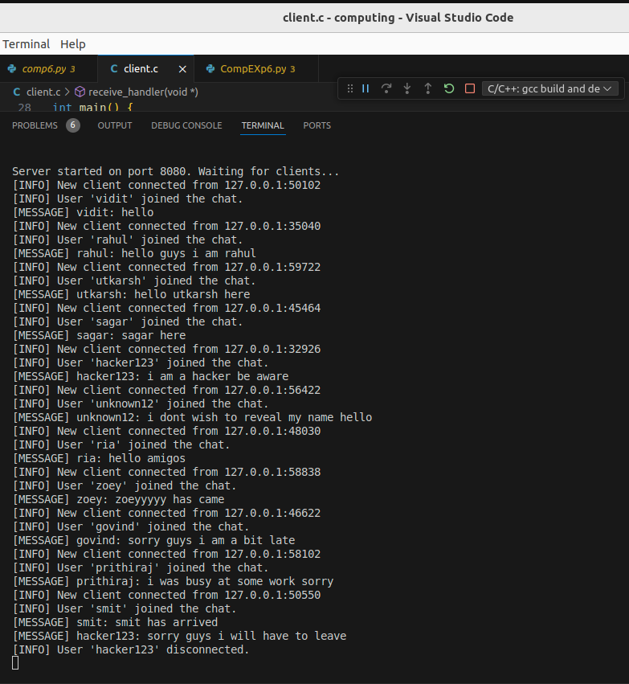

Client 1 side:
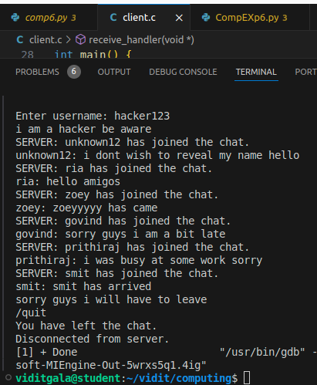

Client 2 side:
